Name of paper in the paper’s language

Eva L****á, Rastislav Ď****š, SK
Abstract: In the paper’s language (please, translate also the Abstract label) […].
Keywords: few keywords in the paper’s language separated by commas (please, translate also the Keywords label).
Name of paper in English
(if the paper is not written in English)
Abstract: In English…
Keywords: in English.
1 Introduction
Machine’s parts, industrial equipment and equipment facilitating people’s lives consists of many components. …… These components differ from each other, for example by construction, speed of motion, mechanical parts, surroundings and physical parameters.
Program the Code;
Begin
This is a Code;
Block
End.
They allow components to rotationally move around their own axis.
1.1 Subheading of experimental tests of experimental tests of experimental tests
Sliding bearings are parts of machines, which help to keep the shafts and axes in structurally required positions. They allow components to rotationally move around their own axis. Sliding bearings also carry load from shafts and axes to other parts of machines…
2 Characteristics of experimental tests of experimental tests of experimental tests
For obtaining the value of friction coefficient the Tribotestor ’89 machine was used. ……… Load force is limited by stepper electromotor and screw gear [4]. ……… The shaft is powered by an electric motor. Scheme of sliding pair is in the Figure 1. Friction coefficient of pertinent sliding couple can be determined by the equation: , (1)
Table1: Table description

where Fn is loading force, μ is friction coefficient, a is arm, Q is force of the friction, r is outer radius of the internal bushing.
11 Example of a note “under the line” – near the page footer – a footnote.
12 Another example of such a note.
Sliding bushings made of material CuSn12 were by cutting operation turned ……… mineral gear oil (CASTROL Manual – EP 80 W) was used.
- The material zinc-aluminium bronze CuZn25Al6 with inserted graphite beds is suitable for higher load forces and lower sliding speed.
- Graphite beds serve as lubricating reservoirs and they are diffused on the surface of the bearing.
- They are diffused on the surface of the bearing.
- Lubricating reservoirs serve as graphite beds.
- They cover approximately 20 – 30 % of the whole surface of the bearing.
Figure 1: The scheme of sliding pair
Main advantage of the bearings made of this material, is that they are self-lubricating. Proportions of the bushings are shown in Figure 2. In the Figure 3 is a photograph of the tested sliding pairs made of both parameters.
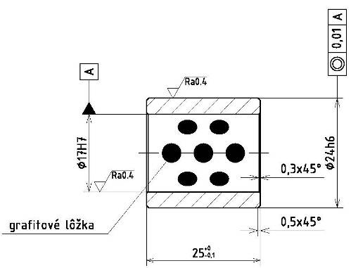  a) internal bushing | 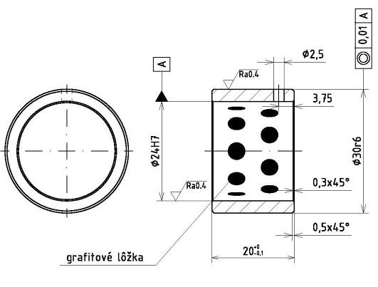  b) external bushing
Figure 2: Parameters of bushings made from material CuZn25Al6
3 Analysis of results
In the work, the results of the size of friction coefficient in dependence on the time are being presented. In all cases with constant load force, after run up the course of friction coefficient in dependence on the time was similar.
Figure 6: Variation of the coefficient of friction in the test with the rectangular shape of loading for bushings from material CuSn12Al6

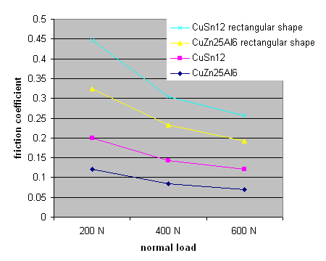  Figure 7: Variation of friction coefficient with the variation of normal load | 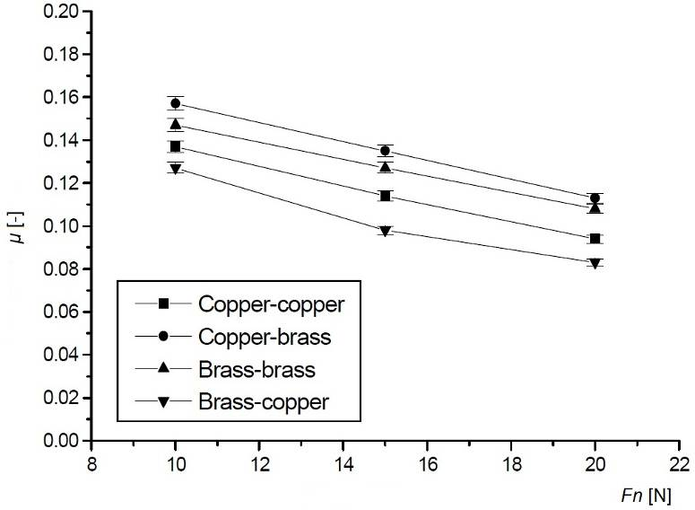  Figure 8: Variation of friction coefficient of normal load for different material pairs [3]
Two graphs are shown for illustration (Figure 5). During ……… for 60 to 70 % and after the run up its value did not markedly changed.
a) Chawdhury et. al. [2] detected similar dependencies of size of friction coefficient,
b) on the size of loading force for different material pairs (Figure 8).
4 Conclusion
The …… Sliding speed of inner bushing was not changed, i.e. its value was all the time 0.8 ms−1. In the observed scope of load (200 N, 400 N, 600 N) the size of friction… In all types of the load, size of friction coefficient for non-lubricated bushings made of CuZn12Al6 with …… made of CuSn12…
Decrease of the value of the friction coefficient with increase of the load probably influences loss of material, smoothing the profile and change of the roughness of the surfaces of both bushings of the sliding pair.
This work has been supported by the Scientific Grant Agency of the Slovak republic VEGA under the Grant No. 1/0390/11 and the Grant No. 1/0389/11.
References
1. Stachoviak, G. W. et al. Experimental methods in tribology. Oxford : Elsevier, 2004. 354 p. ISBN 04-4451-589-5.
2. Chowdhury, M. A. – Nuruzzaman, D. M. – Roy, B. K. – Islam, A. – Hosain, Z. – Hasan, R. Experimental investigation of friction coefficient and wear rate of stainless steel 202 sliding against smooth and rough stainless steel 304 counter-faces. In Friction and Wear Research. Vol. 1 Iss. 3, October 2013, p. 34–41, [on-line] www.‌seipub.‌org/‌fwr.
3. Chowdhury, M. A. – Nuruzzamam, D. M. – Mia, A. H. – Rahaman, M. L.: Friction coefficient of different material pairs under different normal loads and sliding velocities. In Tribology in Industry. Vol. 34, No1, 2012, pp. 18–23, ISSN 0354-8996.
4. Ďuriš, R. – Labašová, E. Experimental determination of the coefficient of friction in rotational sliding joint. In Applied Mechanics and Materials. Vol. 309, 2013, p. 50–54, ISSN 1660-9336 [on-line] ⟨www.‌scientific.‌net/‌AMM.‌309⟩.
Reviewed by: doc. Ing. Milan N****ď, CSc.
Contact address
Ing. Eva L****á, PhD.
Institute of ……… Bratislava
Address…
e-mail: eva.labasova@stuba.sk

